Dual-Arm Robotic Assembly of Discrete Interlocking Brick Structures
(Group 10) Team Members: HOSSAIN Tanvir, SAKIB Sakibul Haque, SHE Yuhang, LI Minjian

1. Introduction
Concept & Goals:
We propose to fabricate freestanding structures assembled from discrete, dry-jointed interlocking brick units (LEGO System bricks) using two cooperating industrial robot arms. The primary purpose of the work is structural and functional: to demonstrate a fully reversible, scaffold-free discrete assembly process in which the fabricated artefact can be disassembled and its material returned to stock without waste. The formal ambition is to build geometries that dry-stacked masonry cannot hold up on its own during construction — cantilevers, overhangs and spanning arches — by using the second robot as transient structural support in place of falsework.
Our main goals include:
- A generalizable image-to-blueprint capability that converts multi-view visual input into machine-readable construction specifications, including brick identity, pose, orientation, and spatial relationships.. [1], [2]
- An autonomous brick manipulation capability that integrates reliable picking, long-range collision-free transport, and RL-based precision insertion, with motion planning handling coarse manipulation and learned control taking over near the target for contact-rich alignment and press-fit engagement. [3]
- A force-aware construction planning and support capability that determines assembly order, identifies structural support requirements, and generates coordinated support-arm motions to maintain stability during fabrication. [3], [4]
- An integrated autonomous dual-arm fabrication pipeline that dynamically coordinates perception, planning, manipulation, support, insertion, and execution feedback across diverse interlocking-brick designs.

Why Robotics:
The second arm as structural support. This is the core argument. Cantilevers and spans in dry-stacked assemblies are unstable during construction and conventionally require scaffolding or falsework. While robots are used in construction for rapid and autonomous assembly. Apart from that, using robots in construction provides a safe environment for the workforce and increases efficiency.
At present most of the construction robots utilize a minimum 6DOF industrial standard dual robotic arm system. The benefit of using 2 arms is that, one arm can be used for holding a partially built sub-assembly precisely, indefinitely, and under a known and monitored load while the first arm completes the joint. This eliminates the falsework entirely and admits forms that neither a single arm nor a human mason could build unaided — and it is the specific capability this proposal sets out to develop and measure.
Performing real time hardware demonstration or even simulation that replicates construction can prove to be quite challenge. Which is exactly where LEGO bricks come to play (no pun intended). LEGO bricks due to their simplicity in shapes and sizes, are widely used for benchmarking robotic assembly, exactly the reason why this project also will utilize LEGO bricks.

2. Related Works

Project 1:
“APEX-MR: Multi-Robot Asynchronous Planning and Execution for Cooperative Assembly” by Philip Huang, CMU (2025)
APEX-MR is a technical systems paper that presents a framework for coordinating multiple robots on cooperative assembly, using LEGO as the main testbed. APEX-MR addresses the core problem that multi-robot assembly offers larger workspace and higher efficiency, but is hard to coordinate under uncertainty, scalability limits, and safety constraints. It builds a three-stage pipeline: first generating a sequential task plan from an assembly sequence with ILP, then planning each task’s motion sequentially with a single-robot planner, and finally converting that plan into a multi-modal temporal plan graph for safe asynchronous execution. The framework’s main idea is to post-process sequential plans so robots can execute them robustly and asynchronously rather than waiting at rigid synchronization points. In experiments on long-horizon LEGO assembly, APEX-MR reduced execution time by 48% versus sequential planning and 36% versus synchronous planning on average. The paper also deploys the method on a real dual-arm system, where it safely coordinates motions and assembles complex customized LEGO structures using commercial bricks. It frames this as the first robotic system capable of customized commercial-LEGO assembly, rather than simple stacking or fixed demos. The overview figure shows the full flow from assembly sequence to task graph, motion plans, and final asynchronous execution graph.
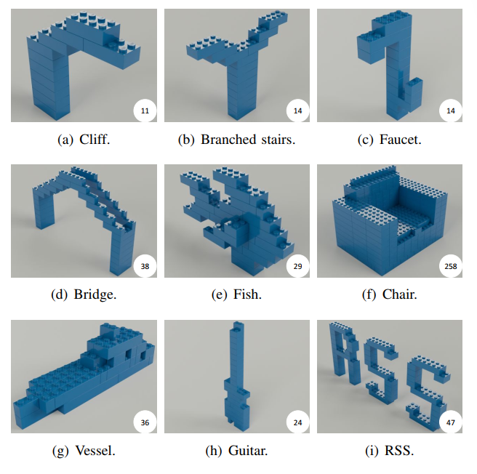
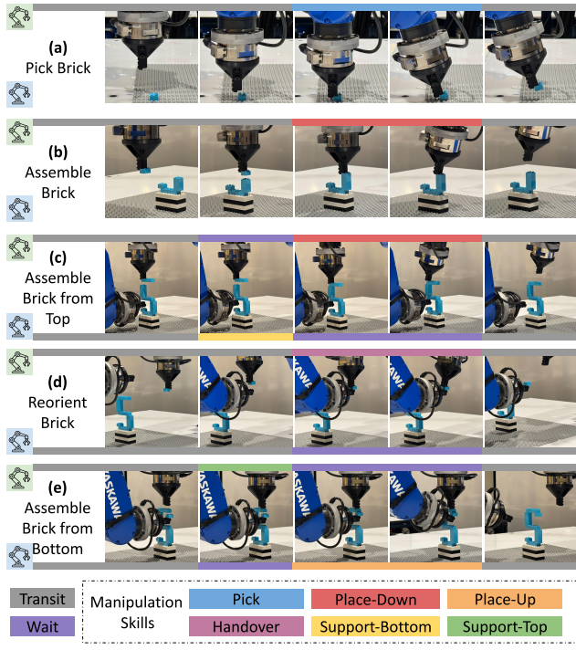
Source: https://github.com/intelligent-control-lab/APEX-MR

Project 2:
“Planning to Build Block Structures with Unstable Intermediate States Using Two Manipulators” by Hao Chen, OSAKA University (2022)
The paper presents an automated assembly and task planner that enables a dual-arm robot to construct block structures containing unstable intermediate states by coordinating one arm to hold the workpiece while the second arm places new blocks. Inspired by human puzzle-solving strategies observed in Soma blocks, the algorithm evaluates geometric meshes and final designs to identify when surface contacts and worktable support are insufficient to prevent collapse. Rather than requiring external fixtures, it evaluates permutations across stability, graspability, and assemblability to dynamically compute assisting supporting grasps. The planner outputs complete execution parameters including optimal assembly order, collision-free candidate grasps, and directional vectors for downstream robotic motion planners. Dual-arm coordination diagrams highlight how the secondary hand acts as an assisting grasp to hold unstable components in place until subsequent blocks re-establish equilibrium. Physical and simulated multi-block experiments demonstrate that the framework reliably discovers feasible construction sequences where single-arm execution fails due to intermediate gravitational instability. While the implementation was tailored to discrete wooden blocks and Soma puzzles, its principles provide a foundational bridge for bimanual assembly of furniture, frames, and complex components
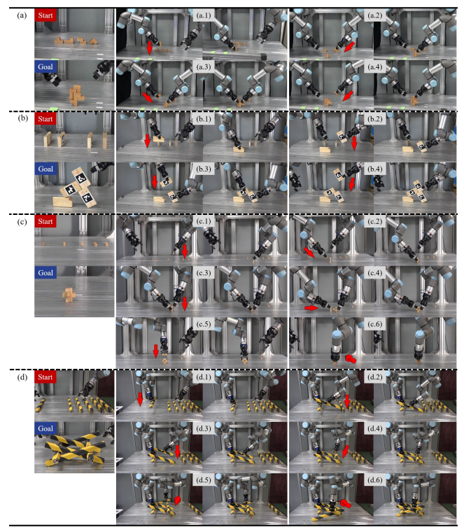
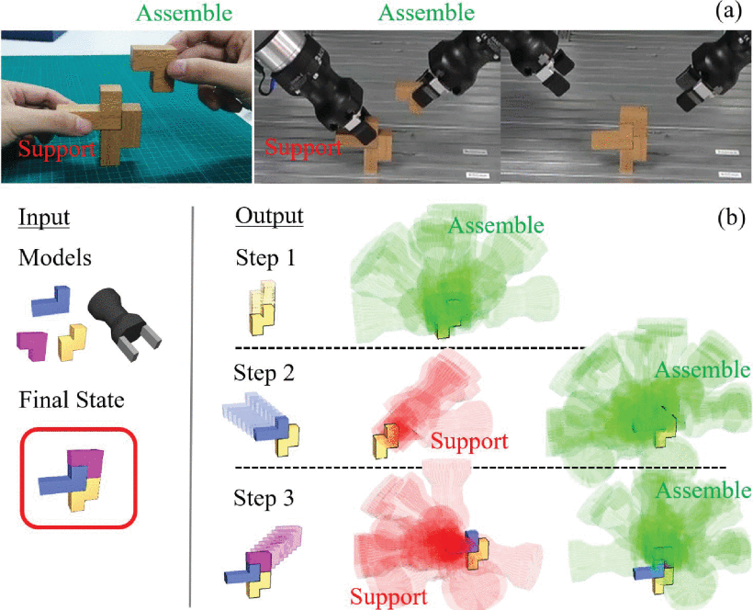
Source: https://ieeexplore.ieee.org/document/9663037

References:
[1] H. Yan and Y. Mu, “Neural Assembler: Learning to Generate Fine-Grained Robotic Assembly Instructions from Multi-View Images,” Apr. 25, 2024, arXiv: arXiv:2404.16423. doi: 10.48550/arXiv.2404.16423.
[2] M. Guo, C. Li, Y. Zhao, and G. H. Lee, “TreeSBA: Tree-Transformer for Self-Supervised Sequential Brick Assembly,” Jul. 22, 2024, arXiv: arXiv:2407.15648. doi: 10.48550/arXiv.2407.15648.
[3] P. Huang, R. Liu, S. Aggarwal, C. Liu, and J. Li, “APEX-MR: Multi-Robot Asynchronous Planning and Execution for Cooperative Assembly,” Aug. 07, 2025, arXiv: arXiv:2503.15836. doi: 10.48550/arXiv.2503.15836.
[4] H. Chen, W. Wan, K. Koyama, and K. Harada, “Planning to Build Block Structures With Unstable Intermediate States Using Two Manipulators,” IEEE Trans. Autom. Sci. Eng., vol. 19, no. 4, pp. 3777–3793, Oct. 2022, doi: 10.1109/TASE.2021.3136006.

